Social Network Analysis

1.
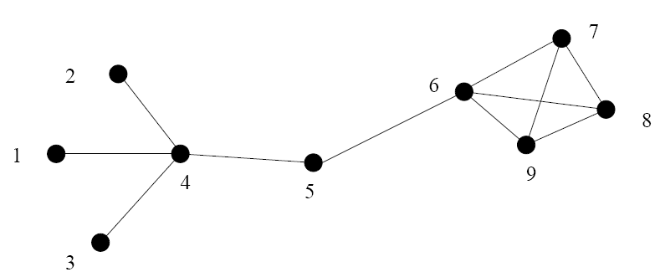
Fig. 1
For the graph in Fig. 1, determine the following:
(a) The average degree.
(b) The degree distribution P(k).
(c) The cluster coefficient C_{i} for each node.
(d) The average cluster coefficient C.

2.
. 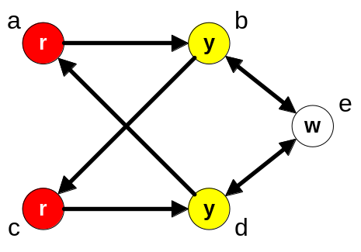
Fig 2

A. Find the structural similarity matrix for Fig 2 where structural similarity is calculated using
  - Pearson’s correlation coefficient,
  - Euclidean distance method.

B Using structural similarity matrix show the steps of hierarchical clustering for this network.

C. Compute
(a) Closeness centrality
(b) Betweenness centrality
(c) Eigenvector centrality
of the network in Fig 2

D. Perform a comparative analysis of these two structural equivalence metrics.

3.
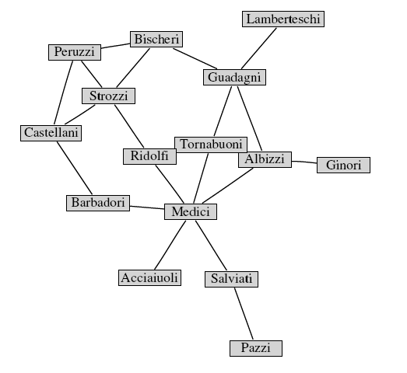
Fig 3
a. Find the degree distribution of the above network. What is the average degree of the network?
b. Find the clustering coefficient of the individual nodes and clustering coefficient of the entire network
c. Calculate the degree centrality and eigenvector centrality of the above network. State the difference between these two in the context of this network
d. Find closeness centrality and between ness centralities using pajek

4.
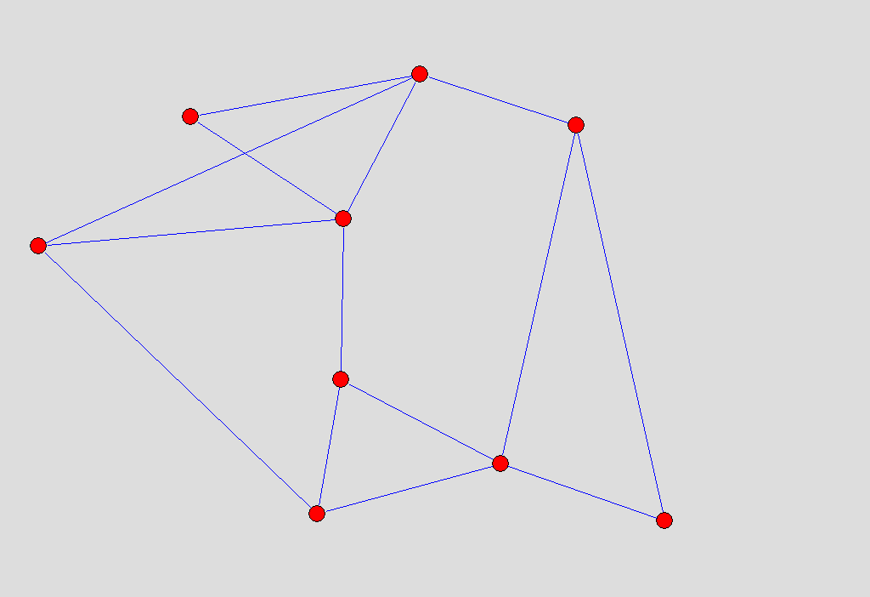
Fig 4
Label the individual vertices of Fig 4. Then find and explain clearly the 2-plex, 2-clan and 2-core from the graph.
5. Show that the clustering coefficient of a regular one dimensional lattice (each node is connected with k nearest neighbors) is
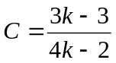
6. In a finite size scale free networks with degree distribution p(k) ~ k^{-γ} and size N, find the maximum degree of the network.
7. The term “scale-free” refers to any functional form f(x) that remains unchanged to within a multiplicative factor under a rescaling of the independent variable x.
Show that, p(x) ~ k^{-x} is a scale free function.
Can you come up with some (four) other functions that are scale free.
8. Show that, the nature of the cumulative distribution for the (a) scale free and (b) exponential distribution remain same, as their original distribution
9. From the definition of the assortativity of a network r, show that
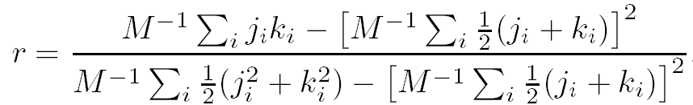
where M is the total number of links and j_{i} and k_{i} are the degrees of the end vertices of edge i.
10. Find the closeness and betweeness centrality of the nodes of Fig 4 and verify the results with pajek. Give the detailed description that how pajec ‘vector’ stores the centrality values of the network.
11. Show that, the power accelerating method to compute the eigenvector centrality do converges after finite time.
12. Consider the following graph where nodes are webpages and links are hyperlinks.
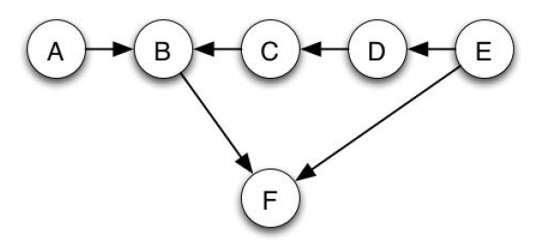

- Which node has the highest pagerank? Explain with the help of detail calculation.
- Add a node G that has two links, one leading to C and one leading to A. Explain the change in the pagerank of other nodes.

